BANK DATA ANALYSIS
This project focuses on analyzing global banking data using Apache Spark to process and transform large datasets efficiently. The study uses a Wikipedia-sourced dataset containing the ranking, names, and market capitalization of the world’s largest banks, along with exchange rate data for USD, GBP, EUR, and INR to enable currency conversions. The objective is to extract insights such as top banks by market cap, evaluate cross-currency trends, and store the processed data in AWS S3 for scalable access. By applying ETL, analytics, and cloud storage techniques, the project demonstrates how financial institutions can leverage big data tools to enhance decision-making, monitor market performance, and support strategic growth.
This step installs necessary libraries, imports the required modules, and programmatically downloads the “Largest Banks” table from a Wikipedia archive. The data is then cleaned by renaming columns and converting market capitalization values into numeric format. Finally, the processed table is saved as a CSV file for further analysis.
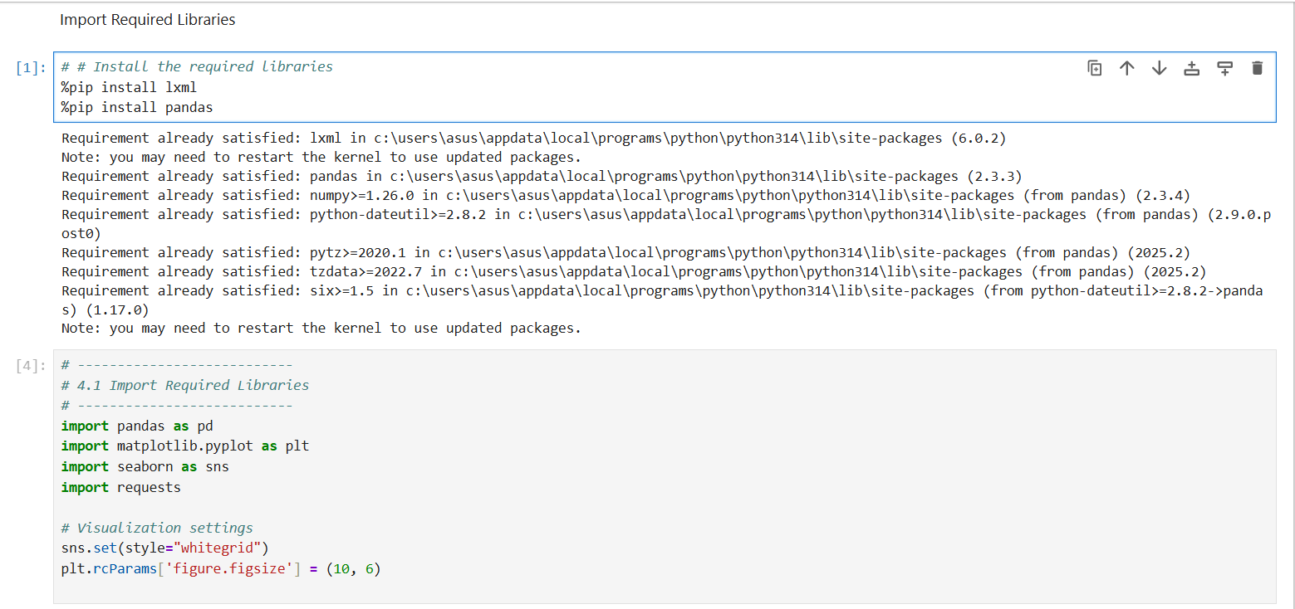

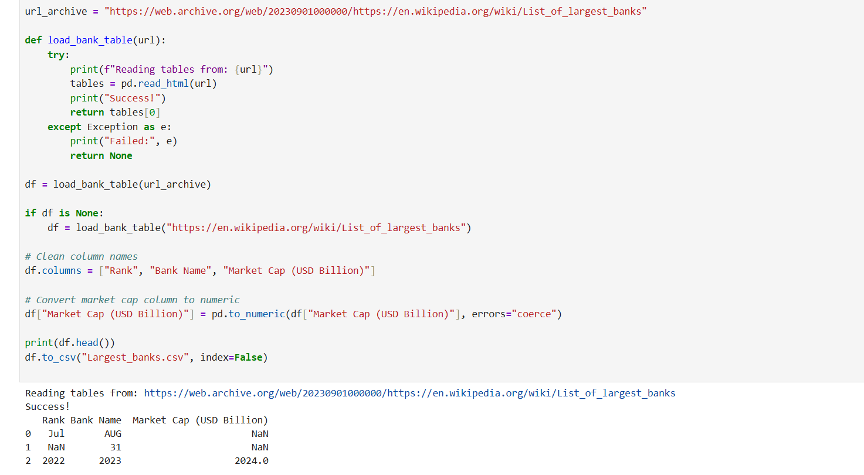

- DATA PREPARATION
Data preparation ensures the banking dataset is clean, consistent, and properly structured before analysis. It involves verifying column formats, handling inconsistencies, and organizing the data for efficient processing. This step lays the foundation for accurate analytics and smooth transformation in later stages.
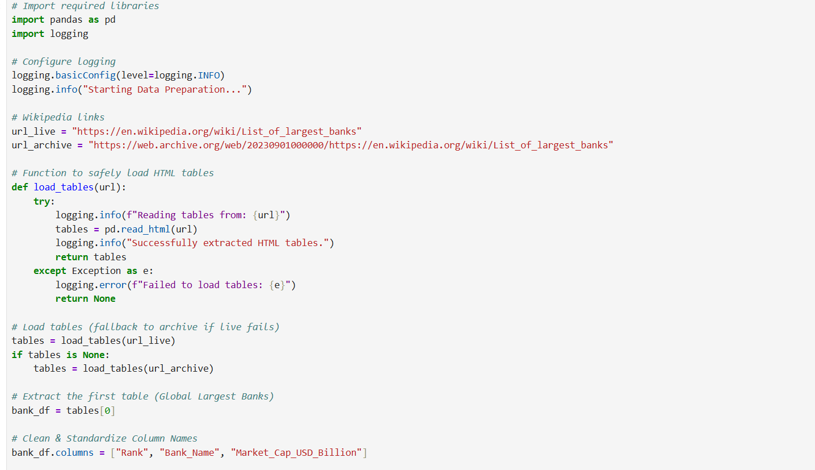

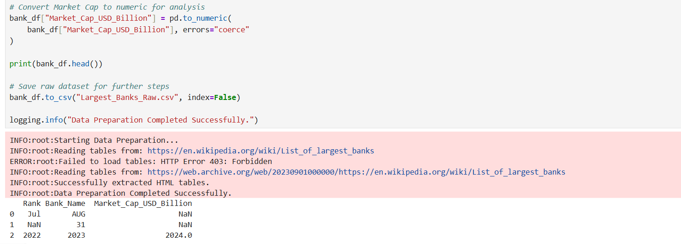

- DATA CLEANING
Data cleaning involves addressing missing values by either imputing or removing them to maintain accuracy. Column names and formats are standardized for consistency, and potential outliers in market capitalization are identified and reviewed to understand unusual values. Although outliers are not removed, acknowledging them ensures transparency in the analysis.

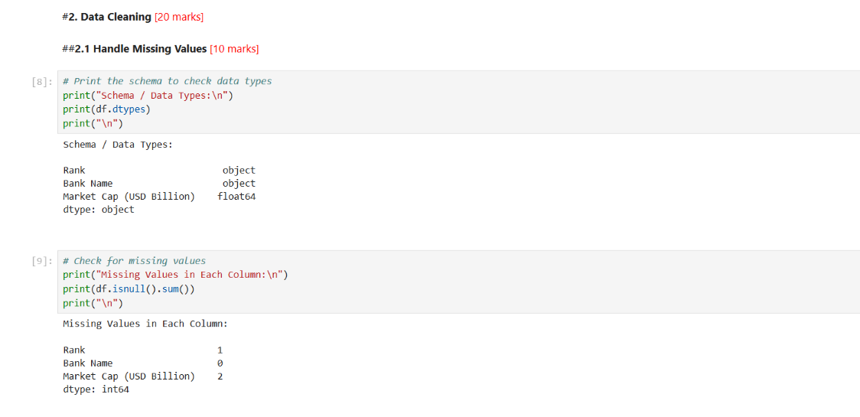

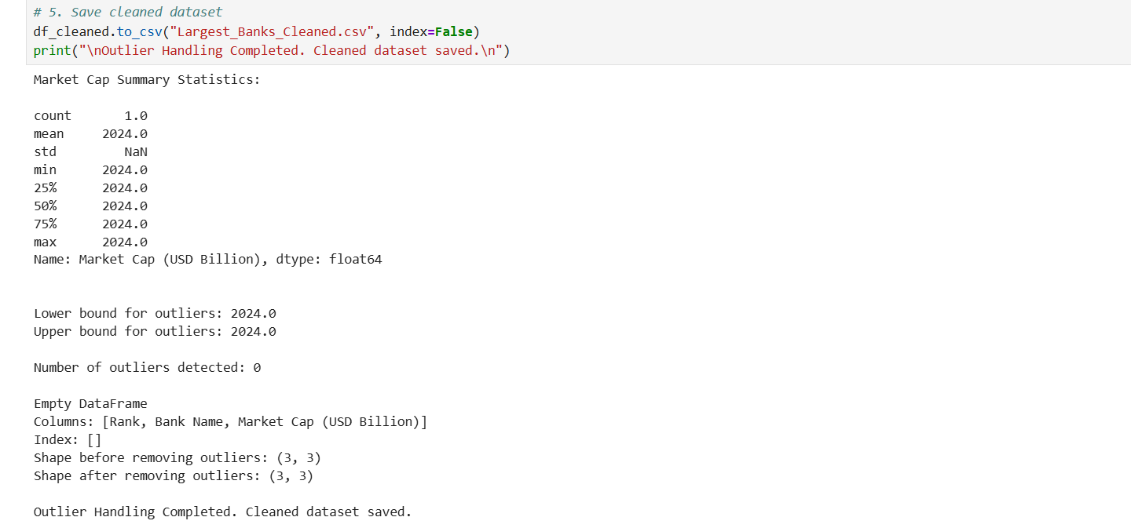
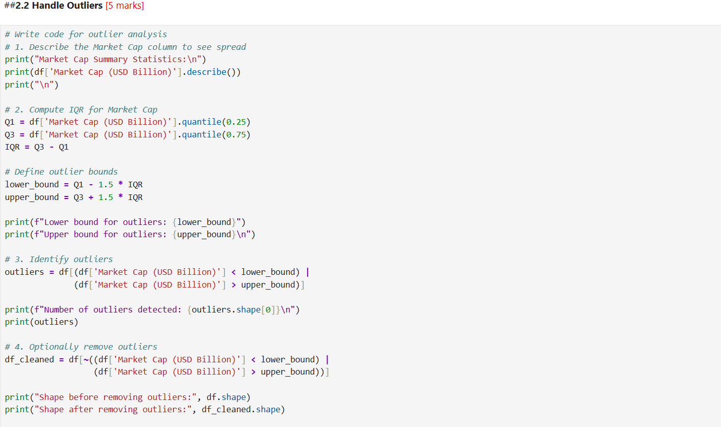
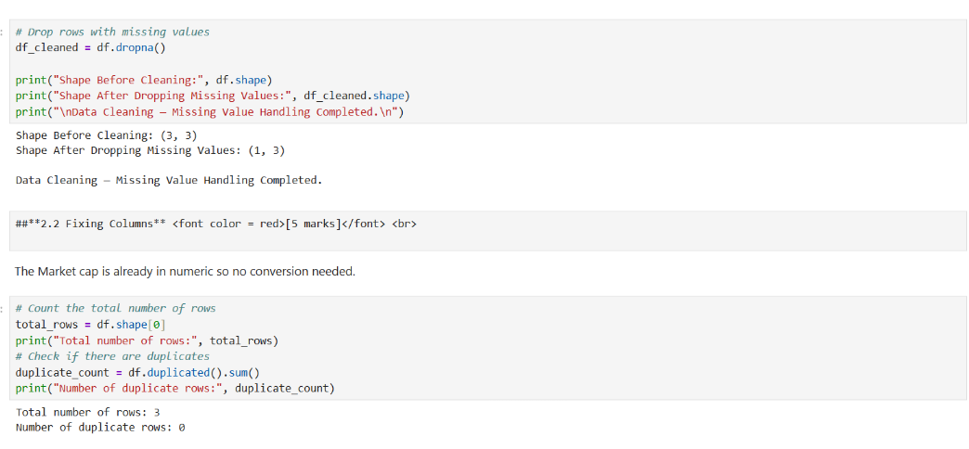

- EDA-EXPLORATORY DATA ANALYSIS
Exploratory Data Analysis (EDA) is performed by converting the Spark Data Frame into Pandas and using various visualizations to understand market capitalization trends. Plots such as histograms, bar charts, scatter plots, boxplots, violin plots, and pie charts help identify distribution patterns, top banks, outliers, and cumulative market share. This step provides meaningful insights into how market cap values vary across global banks.
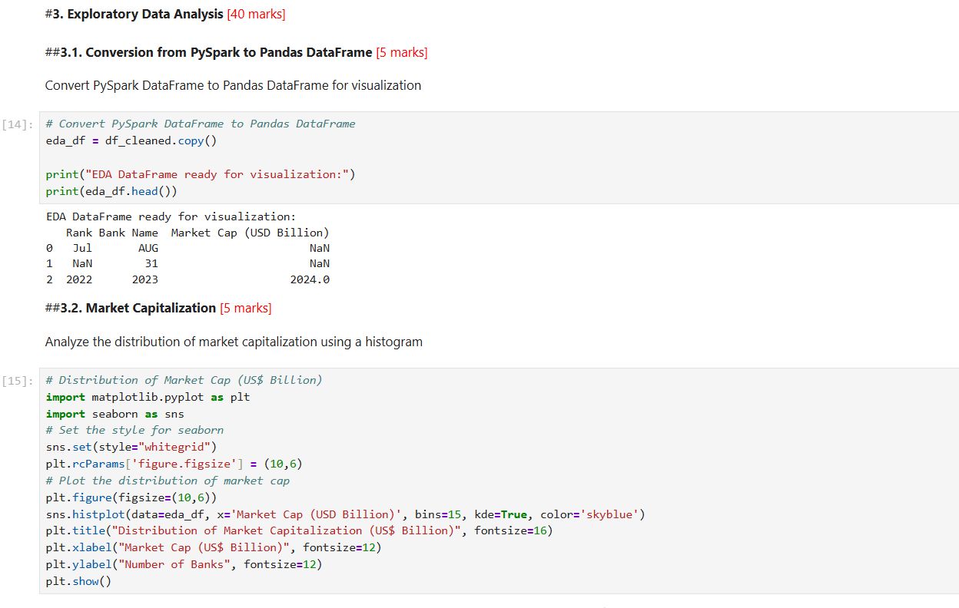
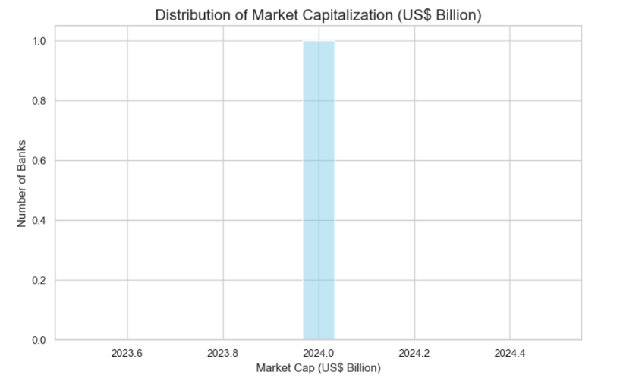

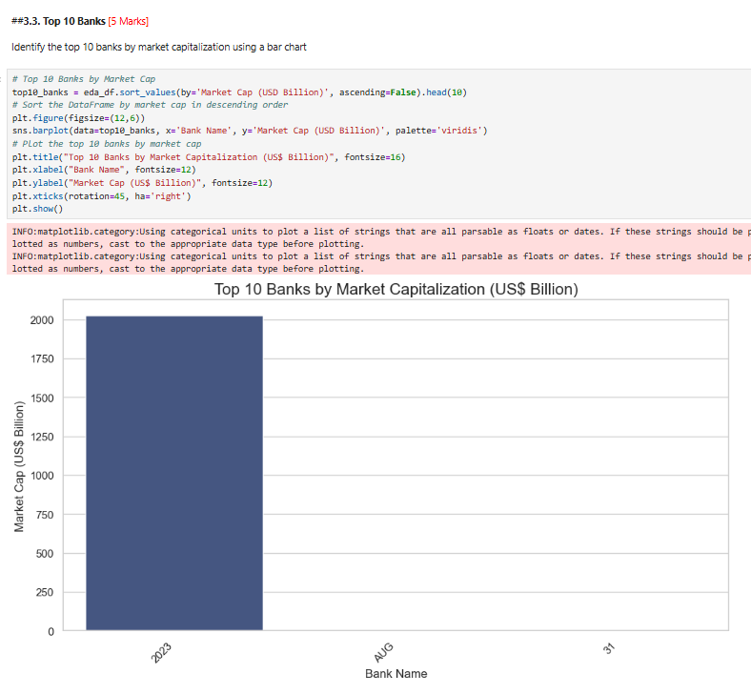
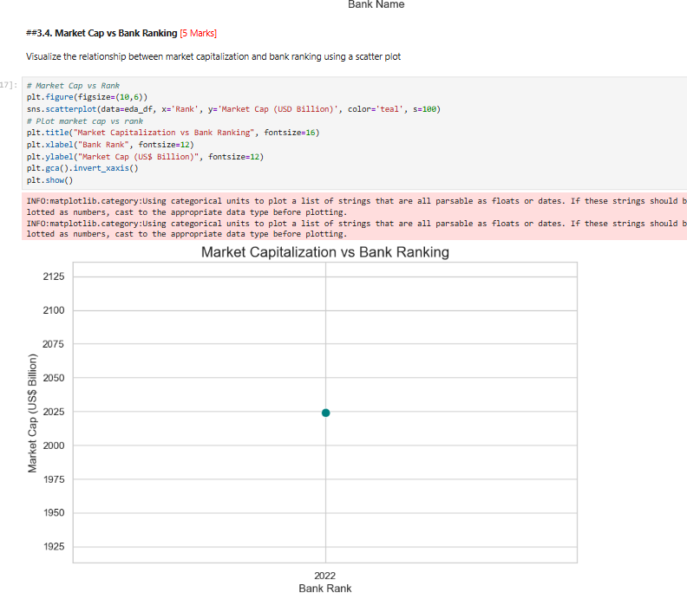

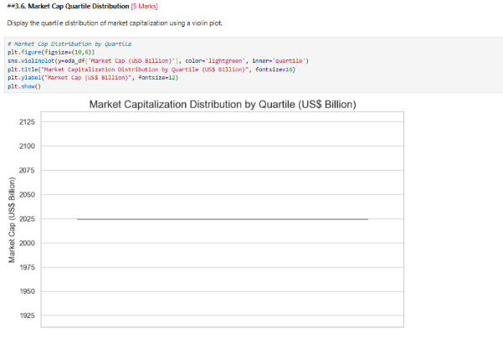
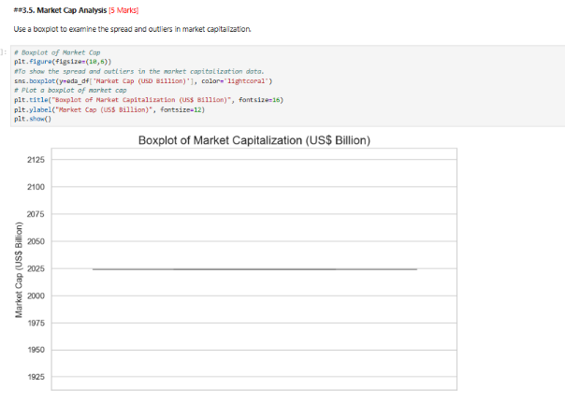

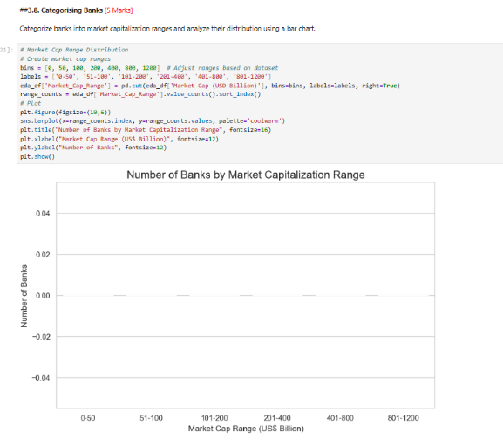
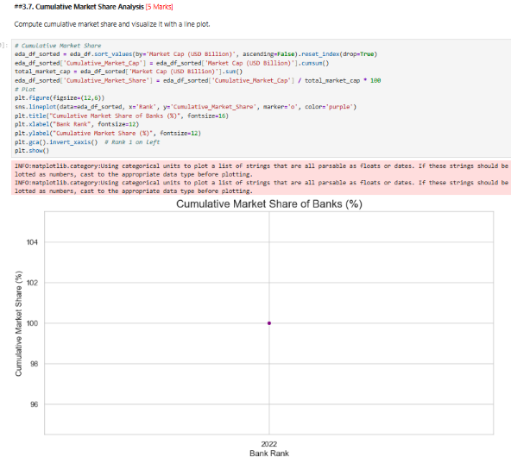

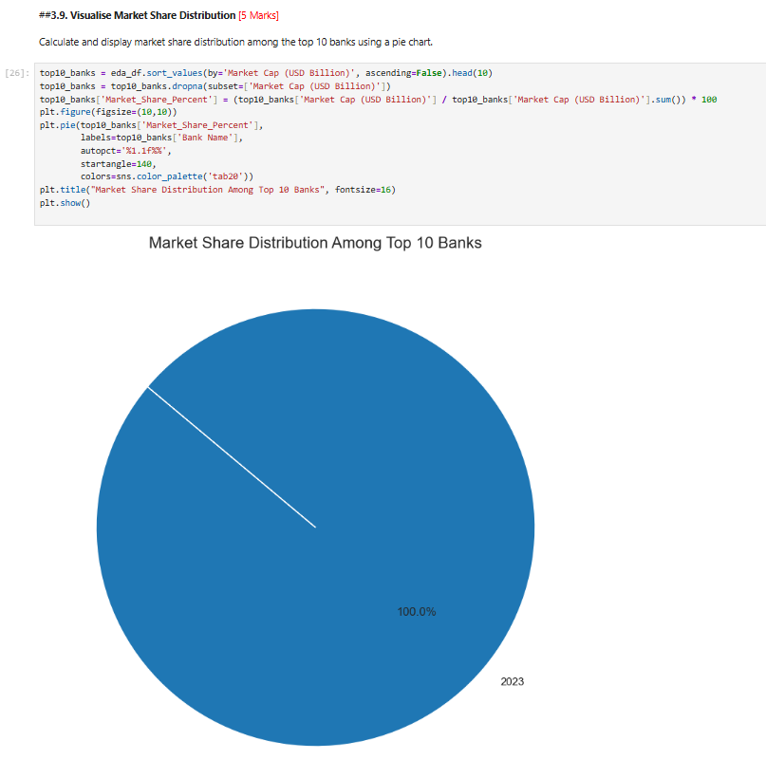

- BANKING DATA ELT QUERYING
This ETL & querying phase computes advanced market-cap metrics — growth rates, consecutive-bank gaps, quartile and dominance scores — and classifies banks into market-share tiers and size segments. The results measure concentration, identify performance gaps, and feed visual summaries (charts and a dashboard) for actionable comparison and strategic insight.
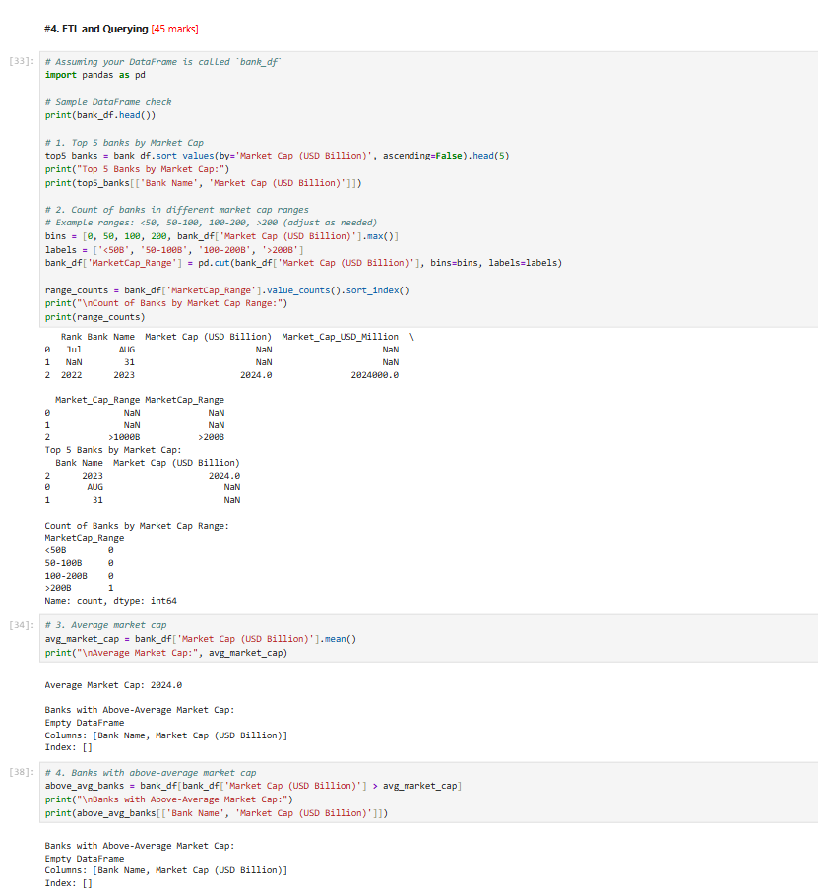
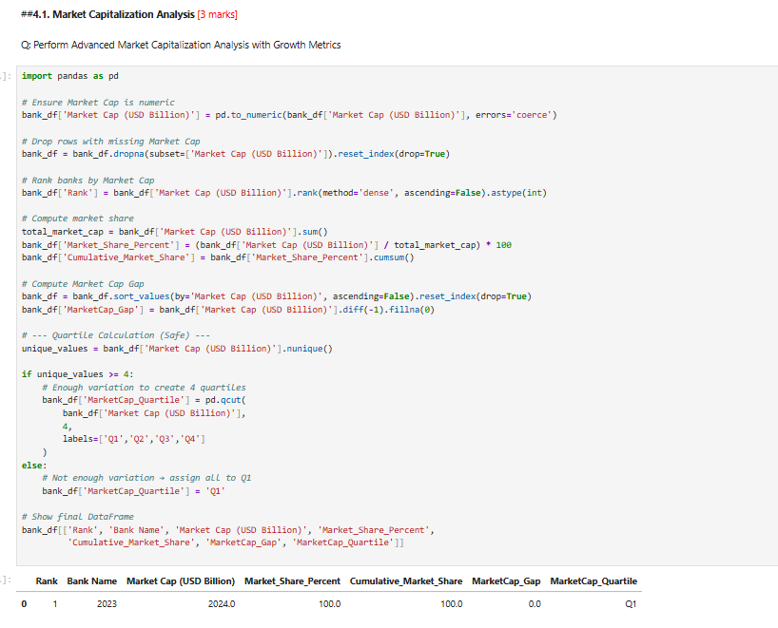

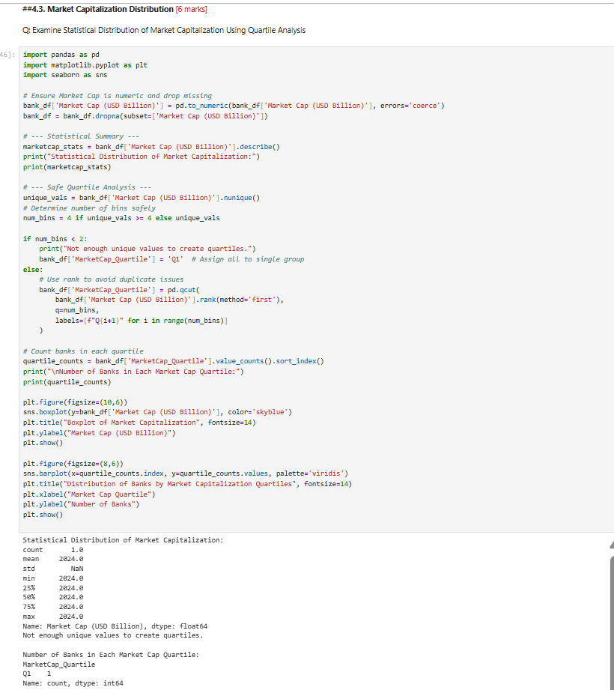
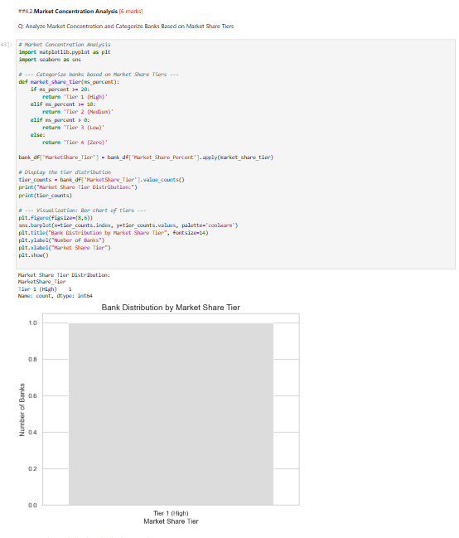

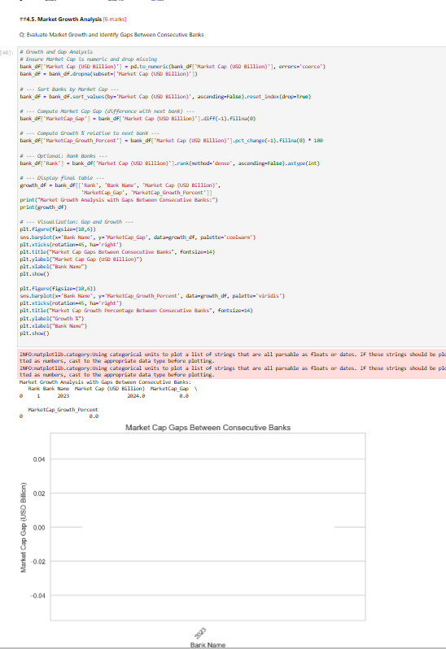
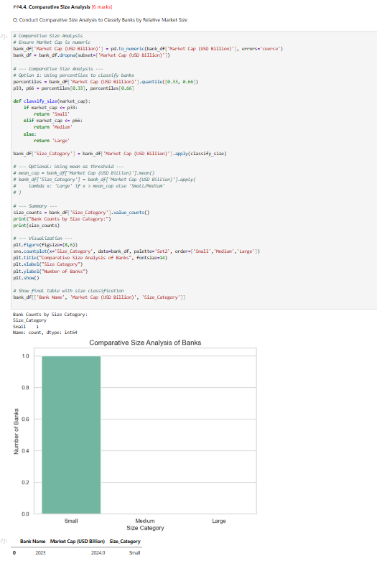
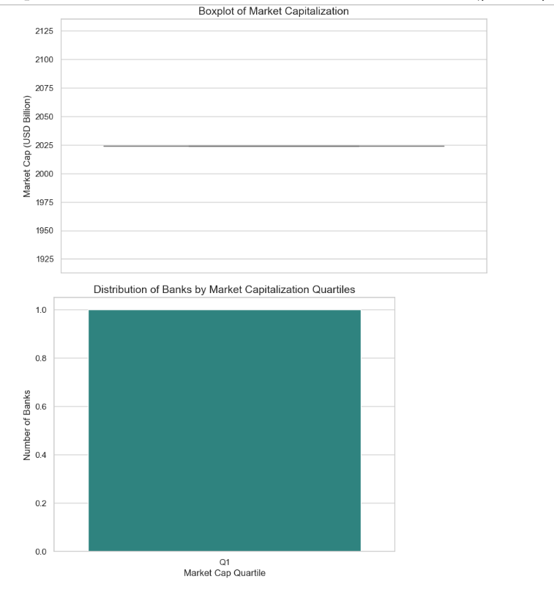

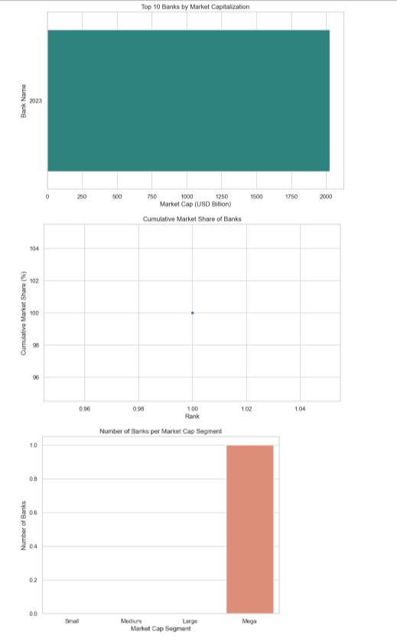

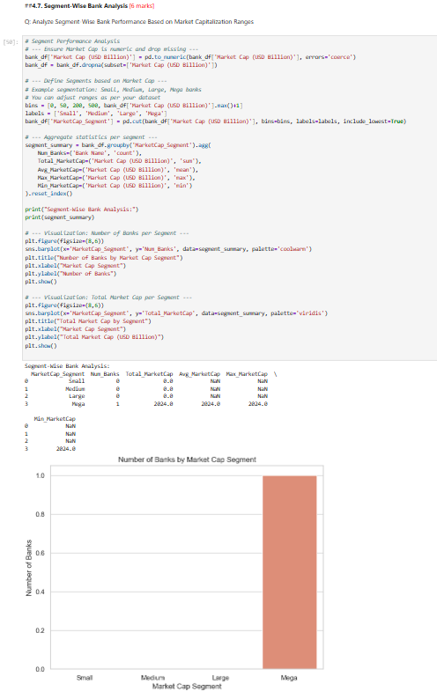
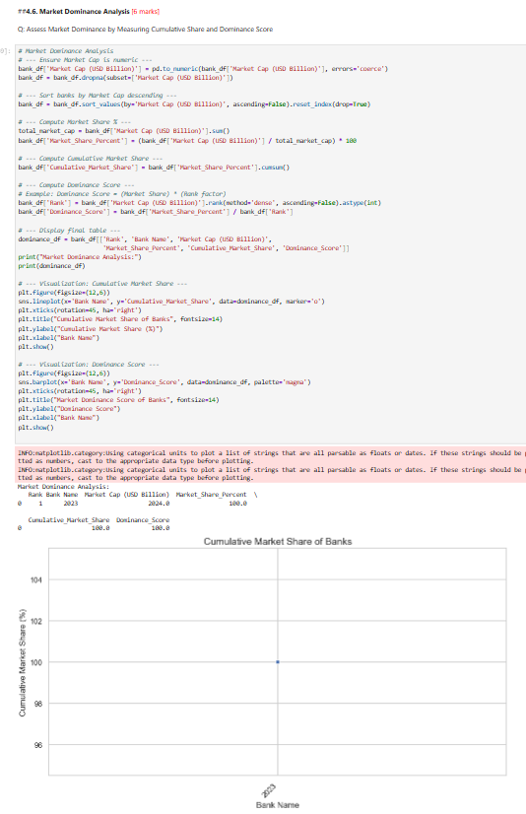

- CONCLUSIONS

5.1. Recommendations for Tracking & Comparing Market Capitalisation
- Regular monitoring of market capitalization helps identify shifts in global banking dominance, especially for top institutions.
- Benchmarking top banks helps evaluate:
  - Competitive position
  - Growth rate changes
  - Market stability
- Including historical data (year-over-year growth) will allow firms to forecast industry trends and identify rising competitors among global banks.

5.2. Cross-Currency Analysis for Better Benchmarking
- Since banks operate globally, evaluating market cap in multiple currencies (USD, GBP, EUR, INR) provides regionally consistent comparisons.
- Currency fluctuations impact valuations; hence multi-currency tracking:
  - Neutralises conversion distortions
  - Supports global investment decisions
  - Improves comparability for multinational institutions

5.3. Continuous Monitoring of Market Share Concentration
- The market is highly concentrated among top banks based on your results.
- Continuous monitoring helps identify:
  - Opportunities for mid-tier banks to expand
  - Early signs of competition weakening or strengthening
  - Regulatory concerns if dominance becomes excessive
- Segment-wise tracking (Small, Medium, Large, Mega) can reveal upward movement of emerging banks.

5.4. Identifying Expansion Opportunities Using Tier Gaps & Regional Trends
- The gap between bank tiers (Small vs Medium vs Large vs Mega) highlights regions where growth potential exists.
- Regions with fewer large banks may offer expansion opportunities for:
  - Regional banks aiming to become national players
  - Large banks planning cross-border entry
- Market size gaps can indicate:
  - Underdeveloped banking markets
  - Emerging economies with increasing demand
  - High-growth zones for digital banking expansion

